Chapter 16, Problem 101.

Realize the transfer function

$$\frac{V_{o}(s)}{V_{s}(s)}=\frac{s}{s+10}$$

using the circuit in Fig. 16.110. Let Y₁ = sC₁, Y₂ = 1/R₁, and Y₃ = sC₂. Choose R₁ = 1 kΩ and determine C₁ and C₂.

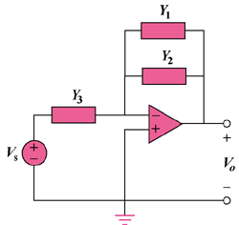

Figure 16.110
For Prob. 16.101.

